192521377-SUBASHREE.N

LAB EXPERIMENTS
EXP 1: DDL Commands – CREATE, ALTER, DROP

OUTPUT:
1:
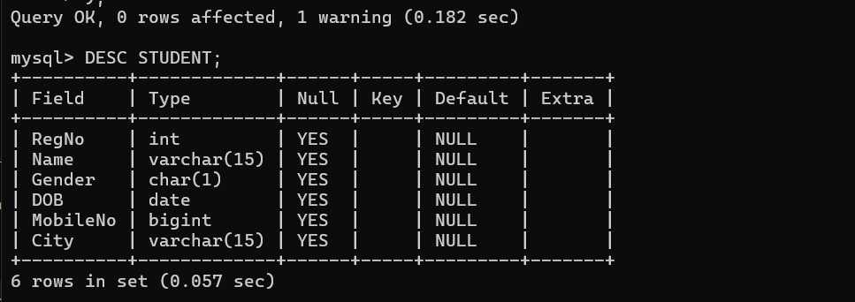

2:
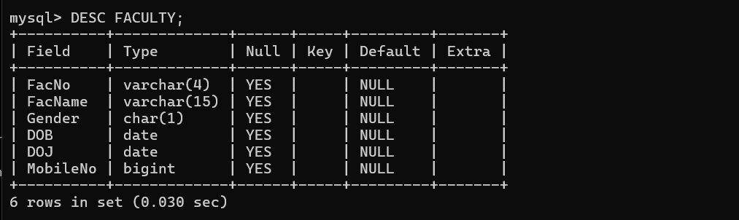

3:
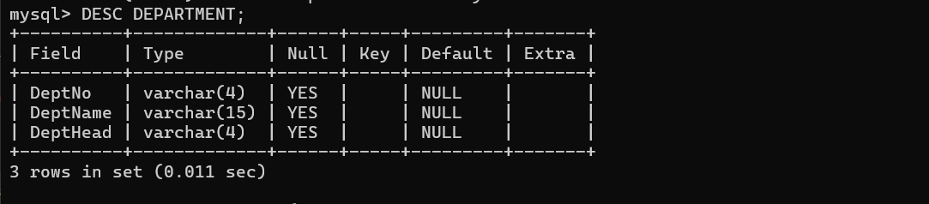

4:
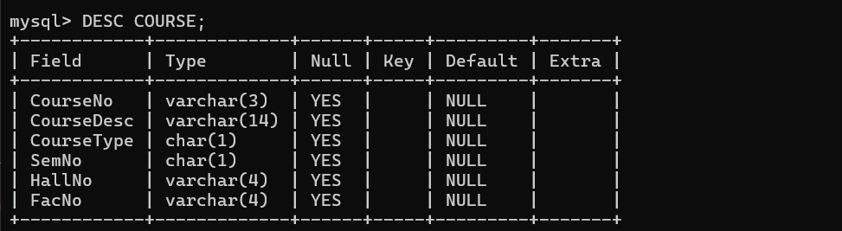

5:
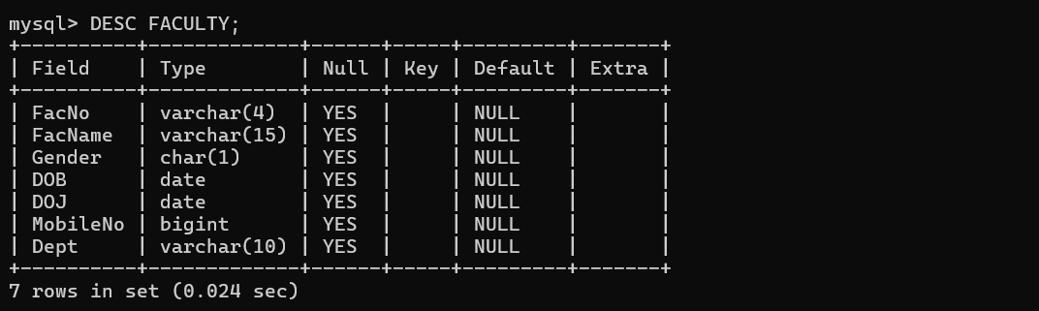

EXP 2: DDL Commands with Constraints – PRIMARY, FOREIGN KEY, UNIQUE, CHECK

OUTPUT:
1:
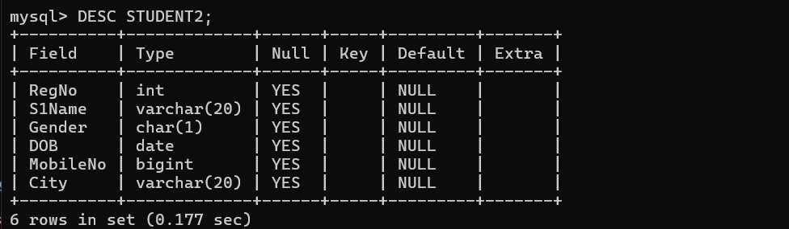

2:
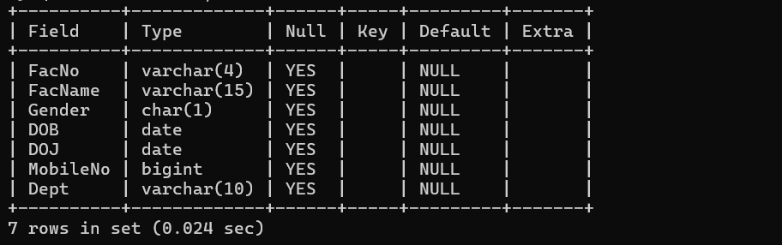
3:
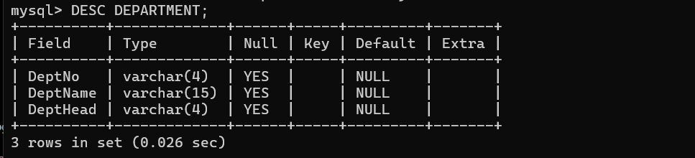
4:
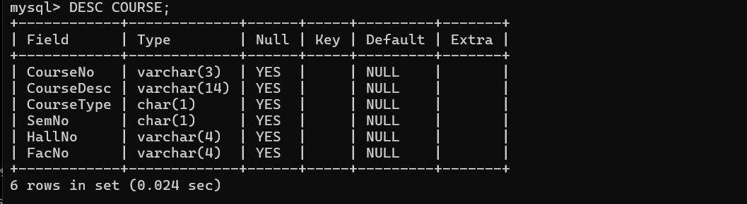
5:
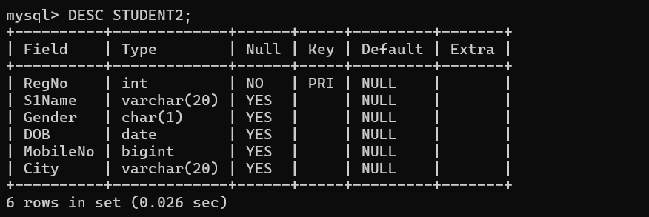

6:
